2007 Q41 2007 Q23

2008 Q37 2008 Q40 2008 Q46 2008 Q48

2009 Q40 2009 Q42 2009 Q22

2010 Q35 2010 Q40 2010 Q42

2011 Q37 2011 Q39 2011 Q40 2011 Q47 2011 Q49

2012 Q33 2012 Q34 2012 Q43 2012 Q48

2013 Q39 2013 Q40

2014 Q43 2014 Q45 2014 Q49 2014 Q39

2015 Q40 2015 Q46 2015 Q23 2015 Q24 2015 Q35 2015 Q36

23. The period of a mass-spring system undergoing simple harmonic oscillation is T. If the amplitude of the mass-spring system’s motion is doubled, the period will be

(a) ¼ T (b) ½ T (c) T (d) 2T (e) 4T

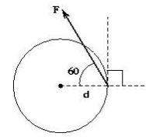

41. For the diagram shown, what is the magnitude of the torque from the applied force as measured from the center of the disk?

(a) Fd sin30 (b) Fd tan30 (c) Fd sin90 (d) Fd sin120 (e) Fd cos120

37. A uniform meter stick has a 45.0 g mass placed at the 20cm mark as shown in the figure. If a pivot is placed at the 42.5cm mark and the meter stick remains horizontal in static equilibrium, what is the mass of the meter stick?

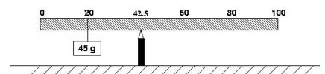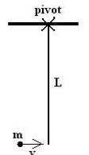

1. 18.0 g (B) 45.0 g (C) 72.0 g (D) 120.0 g (E) 135.0 g

40. A point particle of mass m collides with a thin rod pivoted at one end. The rod has mass M = 2m , length L , and moment of inertia 2 3 1 I = ML . The particle moves horizontally with speed V when it hits the bottom of the rod and sticks to it. What is the speed of the particle immediately after collision?

(A) V 1/3 (B) V 3 1 (C) V 5 3 (D) V 4 3 (E) V 2 3

46. A traveling wave has the form y(x,t) = 3.0sin(2.5 x − 5.0t) where all quantities given are in MKS units, x is position, and t represents time. What is the period of the wave (in seconds)? (A) 2.00 (B) 1.26 (C) 1.00 (D) 0.63 (E) 0.20

48. A block of mass M on a horizontal surface is connected to the end of a massless spring of spring constant k . The block is pulled a distance x from equilibrium and when released from rest, the block moves toward equilibrium. What minimum coefficient of kinetic friction between the surface and the block would prevent the block from returning to equilibrium with non-zero speed?

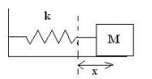

(A) Mg kx 2 2 (B) Mg kx (C) Mg kx 2 (D) kx Mg 2 (E) Mgx k 4

40. A uniform solid cylinder of mass M = 00.2 kg and radius R = 10 0. cm is connected about an axis through the center of the cylinder to a horizontal spring with spring constant m 00.4 N . The cylinder is pulled back, stretching the spring 00.1 m from equilibrium. When released, the cylinder rolls without slipping. What is the speed of the center of the cylinder when it returns to equilibrium?

(A) s .0 577 m (B) s 00.1 m (C) s 15.1 m (D) s 22.1 m (E) s 41.1 m

42. A uniform, solid disk with mass M and radius R is rotating on a fixed, frictionless platform with constant angular speed ω0 about a fixed axis through its center. A second uniform solid disk of mass 2M and radius 2 R is placed from rest directly on top of the first disk so that the centers of the disks line up. When equilibrium is established, the disks are spinning at the same rate. What is the angular speed of the disks at equilibrium?

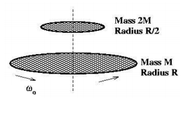

(A) ( ) 0 4 1 ω (B) ( ) 0 3 1 ω (C) ( ) 0 2 1 ω (D) ( ) 0 3 2 ω (E) 0 3 2 ω

22. A point object is connected to the end of a long string of negligible mass and the system swings as a simple pendulum with period T . What is the period of the pendulum if the string is made to have one-quarter of its original length? (A) 4T (B) 2T (C) T (D) T/2 (E) T/4

35. A point object with mass M 2.0kg is attached a distance R 1.75m from the fixed center of a disk as shown in the figure. The disk starts rotating from rest with constant angular acceleration 00 2 5. s rad about an axis perpendicular to the plane of the page through the disk’s center. After how much time (in seconds) is the tangential component of the point object’s acceleration equal in magnitude to the centripetal component of the point object’s acceleration?

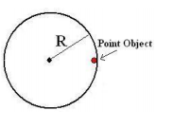

(A) 0.769 (B) 0.592 (C) 0.500 (D) 0.447 (E) 0.350

40. A uniform, solid cylinder with a mass M and radius R is pulled by a horizontal force F acting through the center as shown. The cylinder rolls to the right without slipping. What is the magnitude of the force of friction between the cylinder and the ground?

(A) 1 4 F (B) 1 3 F (C) 1 2 F (D) 2 3 F (E) 3 4 F

42. A comet moves in an elliptical orbit around the sun. As the comet moves from aphelion (the point on the orbit farthest from the sun) to perihelion (the point on the orbit closest to the sun), which of the following results is true? Speed of the comet Angular momentum of the comet/sun system Gravitational potential energy of the comet/sun system

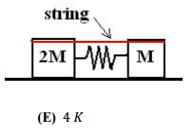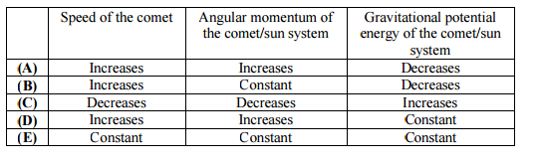

37. Two blocks sit on a horizontal frictionless surface connected to an ideal spring. Initially everything is at rest and there is a string compressing the mass-spring system from equilibrium. At some time after the string is cut, the block of mass 20 reaches its maximum kinetic energy J. What maximum kinetic energy does the block of mass 0 attain in terms of J? (A) G J (B) J (C) J (D) 2 J (E) 4 J

39. An object with mass M moves due East on a frictionless horizontal surface with a speed of L. A second object of mass 1/2M has a speed of 3L. The two objects collide and stick together. If the objects are moving due South after the collision, with what speed are they moving? (A) = L (B) L (C) √= L (D) G√ L (E) √ L

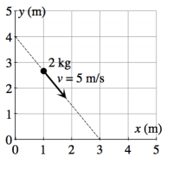

40. A 2.0 particle travels at a constant speed of 5.0 ⁄# along the line shown in the figure. What is the magnitude of the particle’s angular momentum calculated from the origin? (A) 10 · ⁄# (B) 24 · ⁄# (C) 30 · ⁄# (D) 32 · ⁄# (E) 40 · ⁄#

47. A simple pendulum of length has a point mass 0 released from rest from the horizontal position shown. In the absence of air resistance and friction, the mass swings through the arc of a circle. Let 2 represent the magnitude of the force from the string on the mass (tension), 3 represent the magnitude of the gravitational force acting on the mass by the earth, and 4 represent the magnitude of the net force acting on the mass. Which one of the following choices describes the relationship among these forces when the mass swings at the bottom of the arc (point P)?

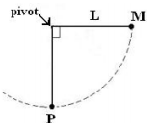

(A) 3 5 4 5 2 (B) 4 5 3 2 (C) 4 5 3 5 2 (D) 2 5 4 5 3 (E) 3 4 5 2

49. An inverted “V” in static equilibrium is made from two uniform beams each of mass 0 12 . Each beam of the “V” has the same length and makes an angle of 30° with the vertical as shown in the diagram. Which one of the following choices best represents the magnitude of the static friction force acting on the left leg of the “V” from the level ground? The coefficient of static friction between each beam and the ground is i( 0.76. (A) 26.3 " (B) 34.6 " (C) 45.6 " (D) 69.3 " (E) 91.2 "

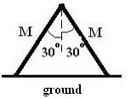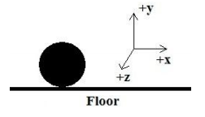

A solid, uniform sphere rolls without slipping on a floor along the -axis (to the right). The rotational kinetic energy associated with the sphere about an axis of rotation through its center of mass along the -axis (out of the plane of the page) is. What is the translational kinetic energy associated with the sphere?

1. (B) (C) (D) (E)

A mass attached to a light string of length is located at an angle below the horizontal as shown in the figure to the right. The mass then is released from rest. Calculated from an axis perpendicular to the plane of the page through the pivot, which one of the following choices represents the magnitude of the torque produced by the gravitational force acting on the mass at this instant?

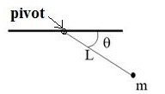

(A) (B) (C) (D) ( ) (E) ( )

Several forces act on a rigid body. If the resultant (net) force on the body is zero, which one of the following statements must be true?

(A) The object is in translational equilibrium and rotational equilibrium.

(B) The object is in translational, but not necessarily rotational, equilibrium.

(C) The object is in rotational, but not necessarily translational, equilibrium.

(D) The object is in static equilibrium. (E) The object is in neither translational nor rotational equilibrium.

An object of mass is dropped from a height above the ground. The object bounces off of a horizontal surface in a collision lasting time . The object then rises upward to a maximum height ⁄ . What was the magnitude of the average net force acting on the mass during the collision with the surface?

(A) ( √ ) √ (B) ( √ ) √ (C) (√ ) √ (D) ( √ ) √ (E) (√ ) √

An ideal uniform solid disk and an ideal uniform ring each have mass and radius . Each object begins purely rolling without slipping down a rough inclined plane. The coefficients of friction for the disk and ring with the incline are .

As each object rolls down the incline, which statement is correct about the force of friction from the incline on the objects?

(A) The ring experiences a greater force of friction than the disk.

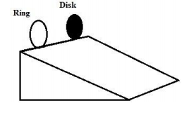

(B) The disk experiences a greater force of friction than the ring.

(C) The force of friction is equal and non-zero for both objects.

(D) The force of friction is equal to zero for both objects.

(E) Nothing can be concluded about the force of friction without more information

40. As the objects roll, what is the ratio of the ring’s angular acceleration to the disk’s angular acceleration calculated about an axis perpendicular to the object’s face and through its center of mass? (A) (B) (C) (D) (E)

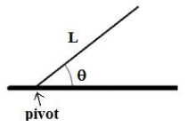

A long rod of length 𝐿 is pivoted about its left end. It is released from an angle 𝜃 above the horizontal. What is the magnitude of the angular acceleration of the rod about the pivot when the rod is released? (A) ( 6𝑔 𝐿 ⁄ ) cos 𝜃 (D) ( 3𝑔 2𝐿 ⁄ ) cos 𝜃 (B) ( 6𝑔 𝐿 ⁄ ) sin 𝜃 (E) ( 3𝑔 𝐿 ⁄ ) sin 𝜃 (C) ( 3𝑔 2𝐿 ⁄ ) sin 𝜃

Two uniform disks, X and Y, have masses 𝑚𝑋 < 𝑚𝑌, equal radii, and equal initial non-zero kinetic energies. Each disk rotates counterclockwise in the plane of the page about a fixed frictionless axis through its center. As shown in the figure, a force 𝐹 is applied tangent to each disk at its right edge for the same amount of time. After the forces are applied, let 𝐿 represent the magnitude of the angular momentum about the center of a disk and 𝐾 represent the kinetic energy of a disk. Which one of the following choices correctly compares these quantities for disk X and disk Y?

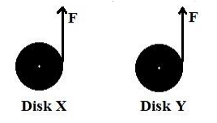

(A) 𝐿𝑋 > ; 𝐾𝑋 < 𝐾𝑌 (B) 𝐿𝑋 > 𝐿𝑌 ; 𝐾𝑋 > 𝐾𝑌 (C) 𝐿𝑋 = 𝐿𝑌 ; 𝐾𝑋 = 𝐾𝑌 (D) 𝐿𝑋 < 𝐿𝑌 ; 𝐾𝑋 < 𝐾𝑌 (E) 𝐿𝑋 < 𝐿𝑌 ; 𝐾𝑋 > 𝐾

. A long thin rod of mass 𝑀 and length 𝐿 is pivoted at one end so that it swings as a pendulum. The rod is set into simple harmonic oscillation and has a period of motion 𝑇. A second thin rod with mass 2𝑀 and length 2𝐿 also is pivoted at one end to swing as a pendulum. When this second rod is set into simple harmonic oscillation, what is its period?

(A) 2 𝑇 (B) √2 𝑇 (C) 𝑇 (D) 1 √2 𝑇 (E) 1 2

49. A solid, uniform disk of mass 𝑀 and radius 𝑅 rotates clockwise about its center with an angular speed 𝜔0. The disk then is placed onto a horizontal surface and begins moving only to the right, slipping as it rolls. The coefficient of friction between the floor and the disk is 𝜇 and the frictional force is considered constant throughout the motion. What is the angular speed of the disk when the disk starts rolling without slipping?

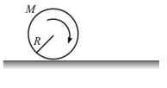

(A) 𝜇 2 𝜔0 (B) 1 2 𝜔0 (C) 1 3 𝜔0 (D) 2𝜇 3 𝜔0 (E) 3 5 𝜔0